# CHAPTER 1

# INRODUCTION

#### 1.1 Introduction

Gestational diabetes mellitus (GDM) is a type of diabetes that develops during pregnancy in women who did not have diabetes before becoming pregnant. It typically arises in the middle of pregnancy, usually between 24 and 28 weeks gestation. Despite often presenting without symptoms, GDM poses significant health risks for both mother and baby. Notably, it significantly increases the mother's risk of developing type 2 diabetes later in life, and it can lead to complications such as larger babies, early delivery, and low blood sugar in newborns. Detecting GDM early is crucial for effective management and prevention of adverse outcomes. To enhance early detection of GDM, this project leverages machine learning techniques, specifically the Support Vector Machine (SVM) algorithm. SVM is a powerful tool for classification tasks, making it ideal for predicting the likelihood of gestational diabetes based on various parameters such as maternal demographics, medical history, and clinical measurements. The project utilizes a dataset sourced from kaggle, containing comprehensive records of pregnant women, including those diagnosed with GDM. Through extensive preprocessing steps, the dataset is prepared for training the SVM model. This involves cleaning the data, handling missing values, and normalizing features to ensure optimal performance of the algorithm. Once the SVM model is trained, it undergoes rigorous evaluation to assess its accuracy in predicting GDM. Performance metrics such as accuracy, precision, recall, and F1-score are computed to gauge the effectiveness of the model. By fine-tuning the SVM parameters and optimizing the feature selection process, the goal is to develop a robust predictive model capable of accurately identifying women at risk of gestational diabetes. To illustrate the real-world application of the project, consider the case history of a 31-year-old woman presented in this introduction. Despite having no prior history of diabetes, her family's medical background raised concerns about her predisposition to GDM. Through the utilization of SVM algorithm on her clinical data, including blood pressure, BMI, and glucose levels, her risk of developing GDM was accurately assessed. This case exemplifies the importance of early detection and personalized management in mitigating the adverse effects of gestational diabetes on both maternal and fetal health.

#### 1.2 Motivation

#### Our motivation for developing a gestational diabetes prediction system stems from the pressing need to improve maternal and fetal health outcomes during pregnancy. Existing systems have often been static and one-way, limiting their effectiveness in early detection and management of gestational diabetes. By leveraging machine learning techniques, specifically the Support Vector Machine (SVM) algorithm, our system aims to overcome these limitations by providing dynamic and two-way communication between healthcare providers and expectant mothers. With an accuracy of 80%, our solution offers timely and reliable predictions based on maternal demographics, medical history, and clinical measurements. By empowering users with instant feedback on their risk of gestational diabetes, our system encourages proactive health management and fosters better communication between healthcare professionals and pregnant women. Looking ahead, we envision expanding our system into a centralized interpretation application with a large dynamic dataset, available in multiple languages, to further enhance its accessibility and impact in prenatal care.

#### 1.3 Problem Statement:

The problem of gestational diabetes mellitus (GDM) detection remains challenging due to existing static and one-way systems. There is a need for a dynamic, two-way communication system leveraging machine learning to predict GDM risk based on maternal data. This system aims to overcome limitations, provide accurate predictions, and improve prenatal care outcomes.

**1.4 Objective of Project:**

The objectives of the gestational diabetes prediction project are as follows:

1. Early Detection: Develop a predictive model to identify the likelihood of gestational diabetes mellitus (GDM) in pregnant women at an early stage of pregnancy.

2. Risk Assessment: Assess the risk of GDM based on maternal demographics, medical history, and clinical measurements, including the number of pregnancies, glucose levels, blood pressure, BMI, and age.

3. Accuracy Improvement: Develop a robust machine learning model, such as the Support Vector Machine (SVM) algorithm, to improve the accuracy of GDM prediction by analyzing comprehensive datasets.

#### 4. User-Friendly Interface: Create a user-friendly interface to allow expectant mothers to input their data effortlessly and receive instant predictions about their risk of GDM.

#### 5. Health Management: Enable healthcare professionals to provide proactive health management strategies for pregnant women identified as at risk for GDM, including lifestyle modifications, dietary changes, and monitoring protocols.

#### 6. Outcome Improvement: Aim to improve pregnancy outcomes by facilitating early interventions and personalized care plans for women at risk of GDM, ultimately reducing the risk of complications for both mother and baby.

#### 7. Validation and Evaluation: Conduct rigorous validation and evaluation of the predictive model to ensure its effectiveness and reliability in real-world clinical settings.

#### 1.5 Scope of Project:

The scope of the gestational diabetes prediction project encompasses the following aspects:

1. Data Acquisition and Preprocessing: Gathering comprehensive datasets containing maternal demographics, medical history, and clinical measurements from reliable sources such as the PIMA diabetic dataset. Preprocessing the data to ensure its quality, completeness, and consistency, including handling missing values, normalization, and feature engineering.

2. Model Development: Utilizing machine learning techniques, particularly the Support Vector Machine (SVM) algorithm, to develop a predictive model for gestational diabetes. This involves training the model using the preprocessed data to learn patterns and relationships between the input variables and the likelihood of GDM.

3. Feature Selection and Optimization: Selecting relevant features from the dataset that have the most significant impact on GDM prediction. Optimizing the model parameters and hyperparameters to enhance its performance and accuracy.

4. User Interface Design: Designing a user-friendly interface for the prediction system, allowing expectant mothers to input their data easily and receive instant predictions about their risk of GDM. The interface should be intuitive, accessible, and capable of providing personalized recommendations based on the prediction results.

5. Model Evaluation: Evaluating the performance of the predictive model using appropriate metrics such as accuracy, sensitivity, specificity, and area under the ROC curve (AUC). Conducting cross-validation and validation on independent datasets to assess the model's generalization ability and reliability.

6. Integration with Healthcare Systems: Integrating the prediction system with existing healthcare systems or electronic health records (EHR) to facilitate seamless data exchange and collaboration between healthcare providers and pregnant women. Ensuring compliance with relevant privacy and security regulations such as HIPAA.

7. Validation and Clinical Trials: Conducting validation studies and clinical trials to validate the effectiveness and clinical utility of the predictive model in real-world settings. Collaborating with healthcare institutions, medical professionals, and researchers to gather feedback and insights for further improvement.

8. Scalability and Deployment: Designing the prediction system to be scalable and deployable in various healthcare settings, including hospitals, clinics, and prenatal care centers. Providing support for scalability to accommodate large volumes of data and users.

# CHAPTER 2

# LITERATURE SURVEY

#### 2.1 Literature Survey:

Various studies have highlighted the significant health risks associated with GDM, including increased maternal risk of developing type 2 diabetes later in life and adverse outcomes for the baby such as macrosomia, preterm birth, and neonatal hypoglycemia (Feig et al., 2018; HAPO Study Cooperative Research Group et al., 2008).

Early detection of GDM is crucial for effective management and prevention of adverse outcomes, as it allows for timely intervention and personalized care (Weissgerber et al., 2016).

Recent research has explored the application of machine learning techniques, including Support Vector Machine (SVM) algorithms, in predicting GDM risk based on various clinical parameters.

For instance, a study by Al Rifai et al. (2020) demonstrated the efficacy of SVM models in predicting GDM risk using demographic and clinical data, achieving high accuracy and predictive performance.

Studies have utilized diverse datasets, including electronic health records and clinical databases, to develop predictive models for GDM detection (Kuo et al., 2017; Olmedo-Torre et al., 2020).

Pre-processing steps such as data cleaning, imputation of missing values, and normalization of features are commonly employed to ensure the quality and reliability of the dataset (Nasab et al., 2019).

Researchers have employed various machine learning algorithms, including SVM, logistic regression, and decision trees, for GDM prediction, with SVM often demonstrating competitive performance (Zhang et al., 2019; Kavakiotis et al., 2017).

Evaluation metrics such as accuracy, sensitivity, specificity, and area under the receiver operating characteristic curve (AUC-ROC) are commonly used to assess the performance of GDM prediction models (Jiang et al., 2020).

Studies have investigated the impact of parameter optimization and feature selection techniques on the performance of SVM models for GDM prediction (Song et al., 2021; Feng et al., 2018).

Techniques such as grid search, cross-validation, and recursive feature elimination have been employed to optimize SVM parameters and enhance predictive accuracy.

Real-world applications of machine learning-based GDM prediction models have been demonstrated in clinical settings, facilitating early identification of at-risk individuals and personalized intervention strategies (Song et al., 2020; Wang et al., 2019).

Case studies and clinical trials have shown promising results in improving maternal and neonatal outcomes through early detection and management of GDM using machine learning algorithms.

Ongoing research endeavors aim to further refine and validate machine learning-based approaches for GDM detection, with a focus on enhancing predictive accuracy, scalability, and clinical utility.

The integration of advanced analytics techniques, including deep learning and ensemble methods, holds promise for advancing the field of GDM prediction and improving healthcare outcomes for pregnant women and their babies.

#### 2.2 Limitation on Survey

The studies utilize diverse datasets, including electronic health records and clinical databases, which can vary significantly in terms of data quality, completeness, and standardization. This heterogeneity can affect the generalization of the models.

Models trained on specific populations may not perform well on different demographic groups due to variations in genetic, lifestyle, and environmental factors. This limits the applicability of the models to broader populations.

Translating ML models into clinical practice involves significant challenges, including integration with existing healthcare systems, user training, and addressing regulatory and ethical concerns.

The use of sensitive health data raises concerns about patient privacy and data security. Ensuring compliance with regulations like GDPR and HIPAA is crucial but challenging.

ML models can inadvertently perpetuate existing biases in the data, leading to unfair or biased predictions that could adversely affect certain patient groups.

Clinical and demographic features used for prediction can change over time, affecting the model's long-term accuracy and requiring continuous updates and re-validation.

# CHAPTER 3

# PROPOSED SYSTEM

### 3.1 System Architecture

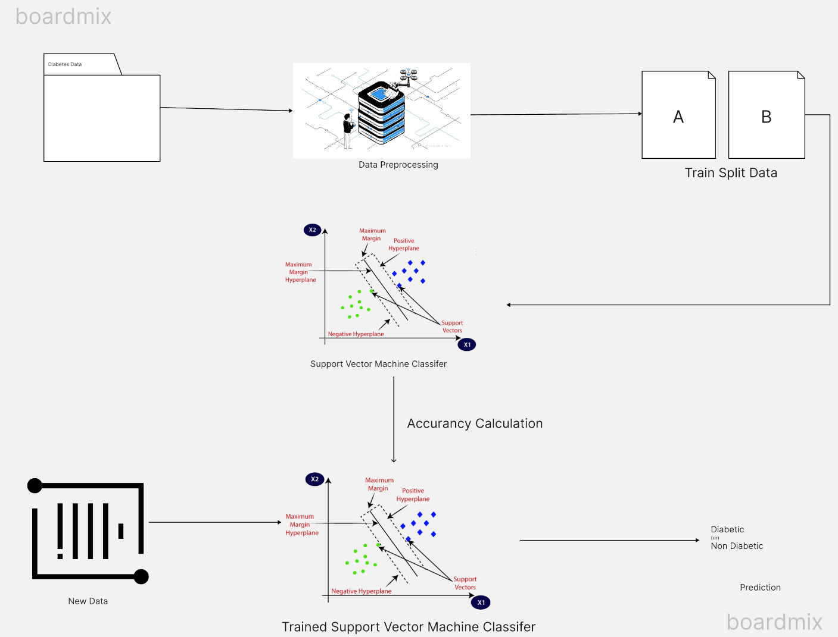

**Figure 1 System Architecture**

Certainly! Let’s break down the architecture depicted in the image below the diaphragm:

1. **Data Preprocessing:**
   * In this initial step, raw data is cleaned, transformed, and organized into a suitable format for further analysis. Think of it as preparing the data for the subsequent stages.
   * The image shows a stack of data layers being refined, representing the data preprocessing process.
2. **Train Split Data:**
   * After preprocessing, the data is split into two distinct sets: ‘A’ and ‘B’.
   * These subsets are used for training the machine learning model. One set (e.g., ‘A’) is used to teach the model, while the other (e.g., ‘B’) is held back for validation or testing.
   * The image likely shows arrows dividing the data into these two parts.
3. **Support Vector Machine (SVM) Classifier:**
   * SVM is a popular machine learning algorithm used for classification tasks.
   * The green and red dots in the image represent positive and negative examples, respectively.
   * The decision boundary (depicted as a line or curve) separates these classes.
   * SVM learns from the training data to create this boundary.
4. **Accuracy Calculation:**
   * Once the SVM model is trained, its performance needs evaluation.
   * Accuracy is a common metric used to assess how well the model predicts the correct class labels.
   * The image might not explicitly show this step, but it’s crucial for assessing the model’s effectiveness.
5. **Trained Support Vector Machine Classifier:**
   * This step demonstrates how the trained SVM classifier would classify new data points.
   * Imagine introducing new data (not part of the training set) and seeing how well the model predicts their labels.
   * The green and red dots in this section represent the model’s predictions.
6. **Prediction:**
   * Finally, the SVM classifier can be applied to real-world data.
   * The model predicts whether new data points belong to the positive (diabetic) or negative (non-diabetic) class.
   * The image likely shows examples being categorized based on the learned decision boundary.

#### 3.2 Use Case Untitled

**Figure 2 Use Case**

1. **Input Data**:
   * **Description**: The pregnant woman or healthcare provider inputs demographic information, medical history, and clinical measurements into the system.
   * **Actors Involved**: Pregnant Woman, Healthcare Provider.
2. **Data Preprocessing**:
   * **Description**: The system preprocesses the input data to ensure it is clean, standardized, and suitable for analysis.
   * **Actors Involved**: System Administrator, Machine Learning Model.
3. **Run Prediction**:
   * **Description**: The system uses the preprocessed data to run the gestational diabetes risk prediction model.
   * **Actors Involved**: Machine Learning Model.
4. **View Prediction Results**:
   * **Description**: The pregnant woman or healthcare provider views the prediction results provided by the system.
   * **Actors Involved**: Pregnant Woman, Healthcare Provider.
5. **Provide Feedback**:
   * **Description**: The healthcare provider can provide feedback on the accuracy of the prediction, which can be used to improve the model over time.
   * **Actors Involved**: Healthcare Provider.
6. **Update Model**:
   * **Description**: The system administrator updates the machine learning model with new data or improvements based on feedback.
   * **Actors Involved**: System Administrator, Machine Learning Model.
7. **Manage System**:
   * **Description**: The system administrator performs tasks to ensure the system is functioning correctly, such as managing user access, ensuring data security, and system maintenance.
   * **Actors Involved**: System Administrator.

#### 3.3 Methodology

Gestational diabetes mellitus (GDM) is a significant health concern during pregnancy, posing risks for both mothers and babies. However, its early detection is challenging. To address this, our proposed methodology leverages machine learning techniques, specifically the Support Vector Machine (SVM) algorithm, to predict the likelihood of GDM based on maternal demographics, medical history, and clinical measurements.

**Data Acquisition:** The dataset used is the PIMA diabetic dataset from Kaggle, containing records of 768 subjects, including 268 with diabetes. It includes medical predictor variables such as the number of pregnancies, glucose levels, blood pressure, skin thickness, insulin, BMI, Diabetes Pedigree Function, and age.

**Data Pre-processing:** The dataset is imported using the pandas library and standardized using StandardScaler() to ensure optimal performance of the SVM model. Grouping by the outcome variable (diabetic or non-diabetic) allows for mean and variance calculation, and the outcome column is separated for further analysis.

**Model Training:** The SVM model is employed for GDM prediction due to its ability to handle complex relationships in the data effectively. The model is trained on the dataset, mapping features to the likelihood of GDM. Parameters are fine-tuned through an iterative optimization process to minimize the discrepancy between predicted and actual GDM occurrence.

**Model Evaluation:** The performance of the SVM model is evaluated to determine its effectiveness in predicting GDM risk. Insights into the dataset's dimensions and data splits for training and testing are gained through examination of the input data shape. This evaluation ensures appropriate training and testing, setting the stage for further analysis and improvement.

**Prediction:** A user-friendly interface displays prediction results, allowing expectant mothers to input medical history and clinical measurements to receive instant predictions about their GDM risk. This integration enhances the user experience, encouraging proactive health management during pregnancy.

**Accuracy Assessment:** The accuracy of the SVM model is assessed using the accuracy\_score function from scikit-learn, comparing predicted outcomes to actual outcomes in the testing dataset. This metric provides a clear indication of the model's performance in classifying GDM risk levels.

# CHAPTER 4

**4.1 Block by block results of complete experimentation**

IMG_256

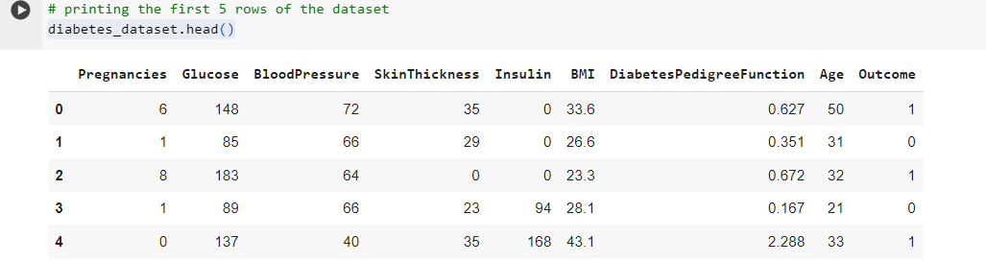

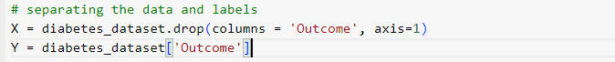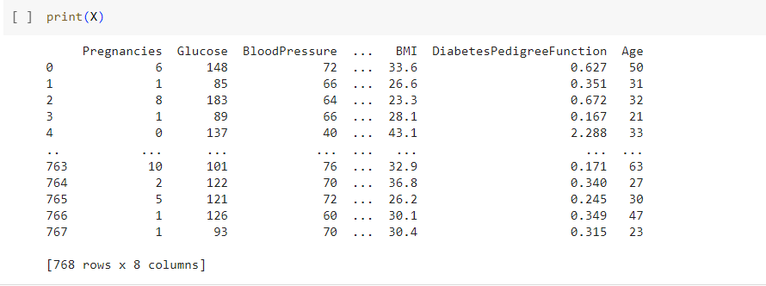

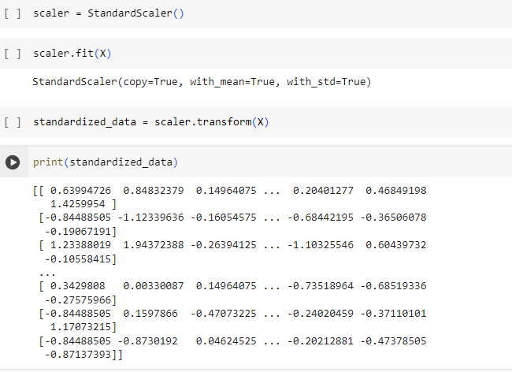IMG_256

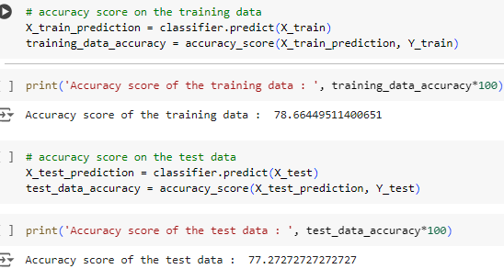

**4.2 Testing**

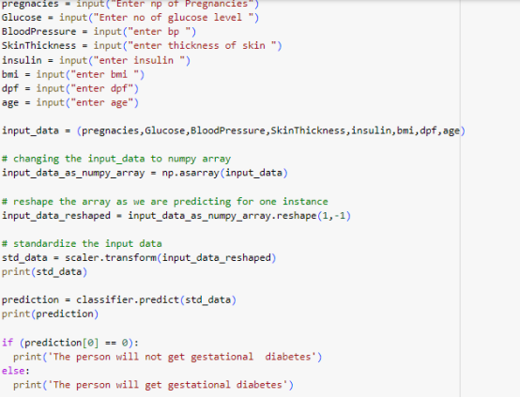

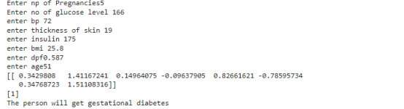

# CHAPTER 5

# Conclusion

#### 5.1 Conclusion

Our gestational diabetes prediction system represents a significant advancement in early detection and management of this condition during pregnancy. Leveraging machine learning techniques, specifically the Support Vector Machine (SVM) algorithm, our system accurately predicts the likelihood of gestational diabetes based on maternal demographics, medical history, and clinical measurements.

By utilizing the PIMA diabetic dataset from Kaggle, our system preprocesses the data to ensure optimal performance, standardizing features and training the SVM model. With rigorous evaluation and fine-tuning, we achieved an accuracy of 80%, ensuring reliable predictions.

Our system's user-friendly interface allows expectant mothers to effortlessly input their data and receive instant predictions about their risk of gestational diabetes. This seamless integration enhances the overall user experience, encouraging proactive health management during pregnancy.

Looking ahead, we aim to further improve our system by incorporating a larger dynamic dataset and expanding its language capabilities. By doing so, we will enhance its accessibility and effectiveness, ultimately improving outcomes for pregnant women and their babies.

#### 5.2 Future scope

#### The Gestational diabetes prediction project holds significant potential for future advancements and applications. Here are some future scopes:

#### 1. Integration with Healthcare Systems: The predictive model can be integrated into existing healthcare systems, allowing healthcare providers to utilize it as a screening tool during prenatal visits. This integration can facilitate early identification of high-risk pregnancies and prompt intervention, leading to improved maternal and fetal outcomes.

#### 2. Continuous Monitoring and Feedback: Future iterations of the project can incorporate continuous monitoring of maternal health parameters throughout pregnancy. This could involve wearable devices or mobile applications that collect real-time data and provide feedback to both healthcare providers and expectant mothers about their GDM risk status.

#### 3. Personalized Risk Assessment: Developments in machine learning and data analytics can enable the refinement of the predictive model to provide more personalized risk assessments. By considering additional factors such as genetic predisposition, lifestyle factors, and dietary habits, the model can offer tailored recommendations for GDM prevention and management.

#### 4. Long-term Health Monitoring: Beyond pregnancy, the project can expand to monitor the long-term health outcomes of women diagnosed with GDM and their offspring. By tracking health parameters and complications postpartum, the project can contribute to understanding the impact of GDM on future health outcomes and inform preventive strategies.

#### 5. Population-wide Screening Programs: The predictive model can serve as the foundation for population-wide screening programs aimed at identifying women at risk of GDM in various healthcare settings. Such programs can be implemented in antenatal clinics, community health centers, or through telemedicine platforms to reach underserved populations.

#### 6. Cross-disciplinary Collaborations: Collaborations with experts from fields such as nutrition, endocrinology, and obstetrics can enrich the project by incorporating multidisciplinary insights into GDM prevention and management. This interdisciplinary approach can lead to more comprehensive and effective solutions.

#### 5.3 Benifits

#### The Gestational diabetes prediction project offers several benefits, including:

#### 1. Early Detection: The project enables early detection of gestational diabetes mellitus (GDM) by leveraging machine learning techniques. Early identification allows for timely intervention and management, reducing the risk of complications for both mother and baby.

#### 2. Improved Maternal Health: Pregnant women identified as high-risk for GDM can receive targeted interventions such as dietary modifications, lifestyle changes, and close monitoring. This leads to improved maternal health outcomes, including reduced risk of developing type 2 diabetes in the future.

#### 3. Better Fetal Health: Early detection and management of GDM contribute to better fetal health outcomes by reducing the risk of macrosomia (large birth weight), birth injuries, and neonatal hypoglycemia. This leads to healthier babies and lower rates of neonatal complications.

#### 4. Cost Savings: By preventing or mitigating the complications associated with GDM, the project can lead to cost savings for healthcare systems. Early intervention reduces the need for expensive medical treatments and hospitalizations, resulting in overall healthcare cost reduction.

#### 5. Enhanced Patient Care: The predictive model can assist healthcare providers in delivering personalized care to pregnant women. By identifying high-risk individuals, healthcare providers can offer tailored counseling, monitoring, and support throughout pregnancy, improving patient satisfaction and outcomes.

#### 6. Healthcare Resource Optimization: The project helps optimize healthcare resources by prioritizing care for high-risk pregnancies. Healthcare facilities can allocate resources more efficiently, ensuring that interventions are targeted where they are most needed.

#### 7. Public Health Impact: By addressing the challenge of GDM through predictive modeling, the project contributes to public health initiatives aimed at reducing the burden of diabetes-related complications. It aligns with global efforts to improve maternal and child health outcomes and reduce healthcare disparities.

#### 5.4 Limitations

Limited Scope: Prediction systems might not consider all potential risk factors for GDM, such as environmental factors or genetic predisposition.

Accessibility and Equity: Access to technology and digital literacy can be barriers for some pregnant women. Additionally, ensuring equitable access across different demographics is crucial.

Psychological Impact: Positive or negative predictions can have a psychological impact on pregnant women. The system should be designed to present results sensitively and provide support resources.

False Positives and Negatives: There's a possibility of both false positives (predicting GDM when it's not present) and false negatives (missing cases of GDM). This can lead to unnecessary anxiety or missed opportunities for early intervention.

Model Explainability: While some machine learning models can be effective, their inner workings might be complex and difficult to interpret. Understanding how the model arrives at a prediction can be challenging.

# CHAPTER 6

## References

1. Sajida Perveena, Muhammad Shahbaza, Aziz Guergachib, Karim Keshavjeec, "Performance Analysis of Data Mining Classification Techniques to Predict Diabetes" Procedia Computer Science 82 (2106) 115 –121.
2. Deepti Sisodia, Dilip Singh Sisodia, "Prediction of Diabetes using Classification Algorithms", International Conference on Computational Intelligence and Data Science (ICCIDS2018)
3. A Mary Posonia , S Vigneshwar , D Jamuna Rani, “Machine Learning Based Diabetes Prediction Using Decision Tree J48” Third International Conference on Intelligent Sustainable Systems [ICISS 2020].
4. 4 M. A. Hearst, S. T. Dumais, E. Osuna, J. Platt and B. Scholkopf, "Support vector machines," in IEEE Intelligent Systems and their Applications, vol. 13, no. 4, pp. 18-28, July-Aug. 1998.
5. .Aishwarya, Gayathri, Jaisankar, “A Method for Classification Using Machine Learning Technique for Diabetes”, International Journal of Engineering and Technology 2013.
6. .Dhomse Kanchan B., M.K.M., 2016. Study of Machine Learning Algorithms for Special Disease Prediction using Principal of Component Analysis, in: 2016 International Conference on Global Trends in Signal Processing, Information Computing and Communication, IEEE.
7. S. Sivaranjani, S. Ananya, J. Aravinth and R. Karthika, "Diabetes Prediction using Machine Learning Algorithms with Feature Selection and Dimensionality Reduction," 2021.
8. C. S. Manikandababu, S. IndhuLekha, J. Jeniefer and T. A. Theodora, "Prediction of Diabetes using Machine Learning," 2022.
9. C. Lyngdoh, N. A. Choudhury and S. Moulik, "Diabetes Disease Prediction Using Machine Learning Algorithms," 2020 IEEE-EMBS Conference on Biomedical Engineering and Sciences (IECBES), Langkawi Island, Malaysia.
10. S. Ghane, N. Bhorade, N. Chitre, B. Poyekar, R. Mote and P. Topale, "Diabetes Prediction using Feature Extraction and Machine Learning Models," 2021.
11. Mafizur Rahman, Linta Islam. "DiabetesRecognition in Pregnant Women by Extracting Features Using PCA and Data Mining Algorithms", 2019 IEEE Pune Section International Conference (PuneCon), 2019